Instructions For Take-Home Exams Using Exam 4
Exam Type: Remote
Exam Mode: TAKEHOME
- All Students are strongly encouraged to read Exam4 Frequently Asked Questions.
- All Students are required to complete Practice Exam(s) in each of the exam modes.
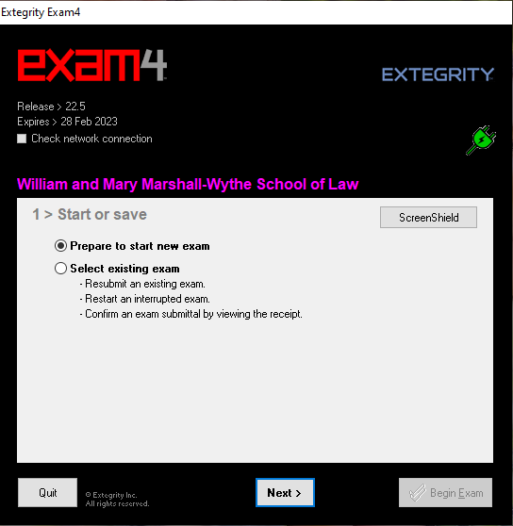
- This tutorial will be helpful when beginning a practice exam or starting your actual exam. Once Exam4 is installed, begin by clicking on the Exam4 software on your desktop.
- Check yes to question, “Do you want to allow this app to make changes to your device?”

- In image 1.0, you are at start-up screen #1. Select Prepare to start new exam.

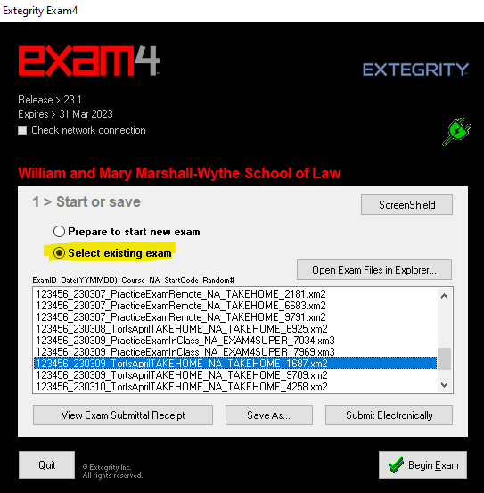
Image 1.0

- If you previously selected ‘Suspend Exam’ on a Takehome exam and are ready to resume and submit, open the Exam4 Software. Once opened, scroll until you find the proper exam, select it, and hit Begin Exam as in image 1.1

Image 1.1

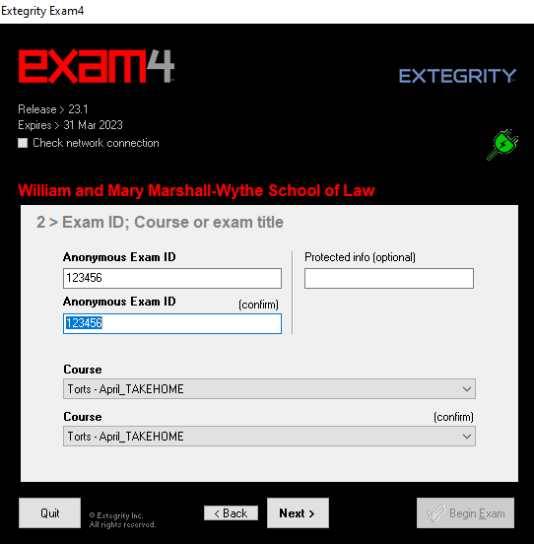
- At start-up screen #2 in image 2.0, enter your Exam ID twice for confirmation.
Protected Info field will help administration locate your exam answers if you entered your Exam ID incorrectly. Students will enter their date of birth MM/DD/YYYY
Select the desired course or practice exam from the drop down menu.
You must make this selection twice for confirmation.
Select Next.

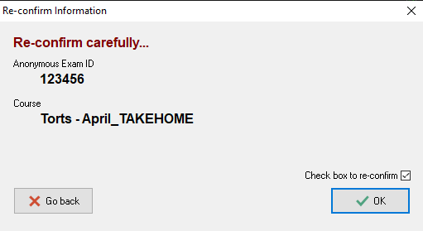
Image 2.0

- A pop-up window will appear. Confirm the exam selection and Exam ID like in image 3.0. Check the box to re-confirm in the bottom corner. Select OK.

Image 3.0

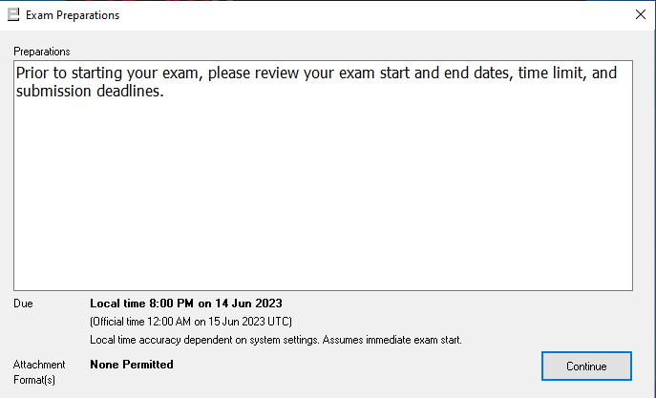
Image 4.0

Image 5.0
A pop-up window titled Exam Preparations will appear. This is where important information is shared before starting an exam. Select Continue.

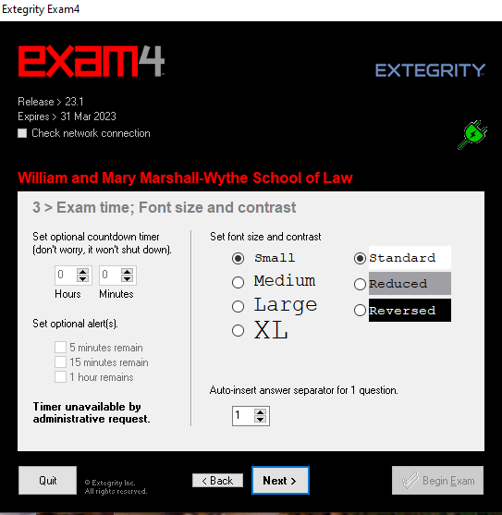
- At start-up screen #3, you can now set an exam timer, font size, and font contrast preferences seen in image 5.0.
The countdown timer is optional for students. If students select this option, and upon the time-limit ending for the exam, the Exam4 software will not shut down, but the exam will be recorded as late. Accommodated students should use their adjusted time (original exam duration + accommodated time) for the timer. Note that you can also set optional alerts for time remaining.
Students can select the preferred font size and font contrast.
Students can auto-insert answer separators for exam questions. Selecting this option means that formatting with defined lines will appear once the student starts their exam. Select Next.
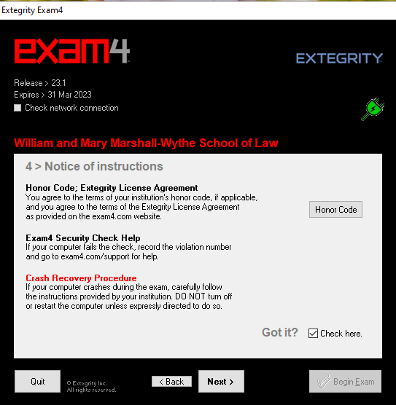
Image 6.0
- At start-up screen #4, you must read the notice of instructions carefully seen in image 6.0.
Once you’ve agreed to the Honor Code, and have read the crash recovery procedures provided on our Exam FAQ website, check the box in the bottom right-hand corner. Select Next.

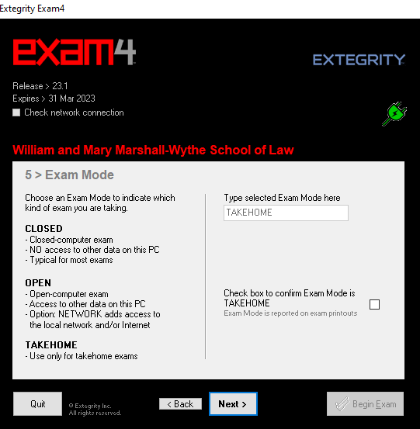
- In image 7.0, start-up screen #5 will confirm Exam Mode. Your exam mode will autofill during the actual exam. The practice exam allows students to enter each exam mode to allow students to 1) test each mode on their PC and 2) get students comfortable with each mode.

Check Box to confirm Exam Mode and click Next.

Image 7.0

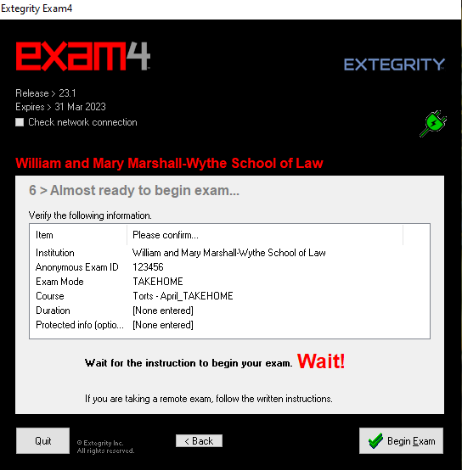
- Confirm exam details. You can go back if you need to make changes.

Click begin exam.

Image 8.0

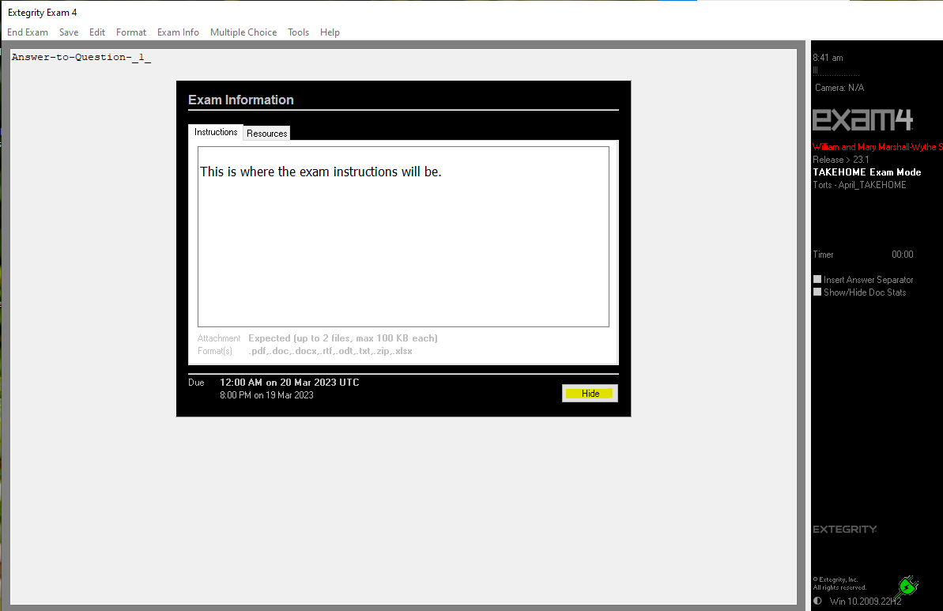Image 9.0
- Once your exam has begun, a pop-up window will appear as seen in Image 9.0. This is where your exam instructions will appear. To view the exam questions select the Resources tab to the right of the instructions tab. Select hide to close this window.
Image 10.0
- If you selected Hide to close your instructions, you can access them again under Exam Info then Remote Exam Info.
Image 11.0
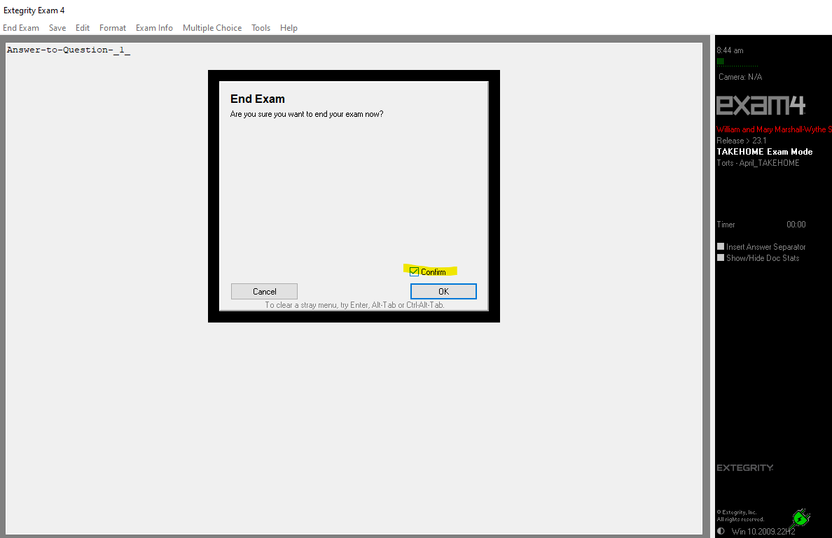
- Once you are ready to suspend or submit your TAKEHOME exam, select End Exam then End Exam now.

Image 12.0

- A pop-up window will appear. Check the box to confirm, then select OK.

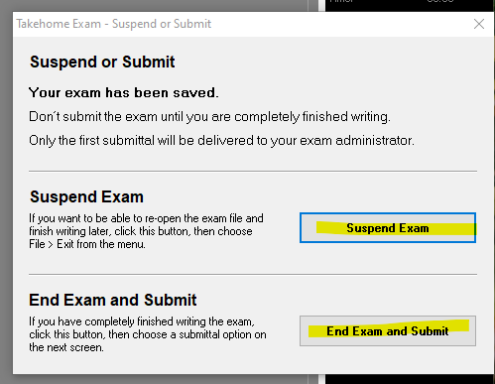

Image 13.0

- A pop-up window will appear with the options to either Suspend Exam or End Exam and Submit.
If you are not ready to submit your Takehome Exam, select Suspend Exam. This will pause your exam and permit you to resume it later. Your document will be autosaved and you will exit the Exam4 Software.
If you are ready to submit your exam click End Exam and Submit.
Takehome exam FAQ:
My takehome exam is 5 hours. Can I work on it 2 hours today, take a break, and use the remaining 3 hours at a later time?
Answer: Once you begin your Takehome exam, in this case, you have 5 hours to complete and submit the exam. The 5 hour limit begins as soon as you begin the exam and will continue running regardless of how many times or how long you choose to suspend the exam. i.e., if you open the exam and suspend it for 4.5 hours, then you will only have 30 minutes to work on the exam and submit it, or it will be counted late.
DO NOT SELECT ‘END EXAM AND SUBMIT’ UNLESS YOU ARE FINISHED.
See below for instructions concerning submission.

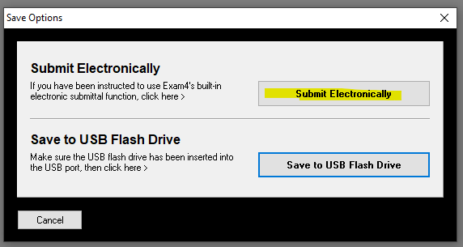
Image 14.0
- Click Submit Electronically

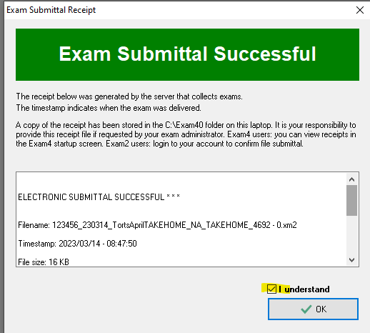
- Once you select Submit Electronically, you will see the Exam Submittal Successful box in image 15.0. You must select ‘I understand’ and click OK.

Image 15.0
Image 16.0
- After clicking OK, click Exit Exam4, then click Exit Exam4 now.
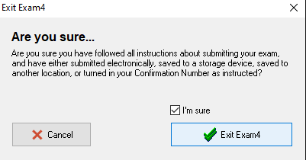 Image 17.0
- Click, “I’m Sure’ and click Exit Exam4 to close the software in image 17.0.

