Instructions For Take-Home Exams with Attachment Upload Using Exam 4
Exam Type: Remote
Exam Mode: TAKEHOME
- All Students are strongly encouraged to read Exam4 Frequently Asked Questions.
- All Students are required to complete Practice Exam(s) in each of the exam modes.
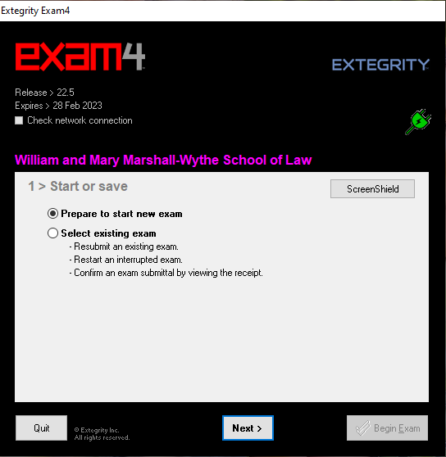
- This tutorial will be helpful if you have a Takehome exam that requires a document upload, i.e. Excel file. The upload feature will not be present on the practice exam because, so few exams use this option. Do not attempt to “practice” a document upload on your actual exam before you plan to start your actual exam.
- To begin, open Exam4 from your desktop. Check yes to question, “Do you want to allow this app to make changes to your device?”

- In image 1.0, you are at start-up screen #1. You can select Prepare to start new exam.

Image 1.0

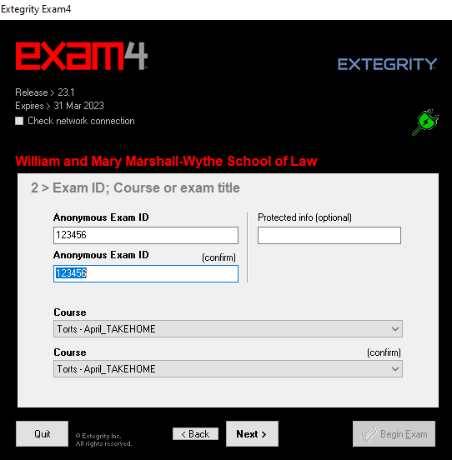
4.At start-up screen #2 in image 2.0, you must enter your Exam ID twice for confirmation.
Protected Info field will help administration locate your exam answers if you entered your Exam ID incorrectly. Students will enter their date of birth MM/DD/YYYY
Select the desired course or practice exam from the drop down menu.
You must make this selection twice for confirmation. Select Next.

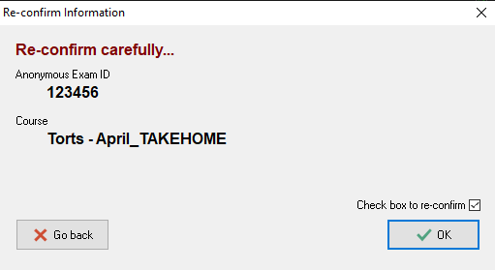
Image 2.0

- A pop-up window will appear. Carefully confirm the exam selection and Exam ID like in image 3.0. Check the box to re-confirm in the bottom corner. Select OK.

Image 3.0

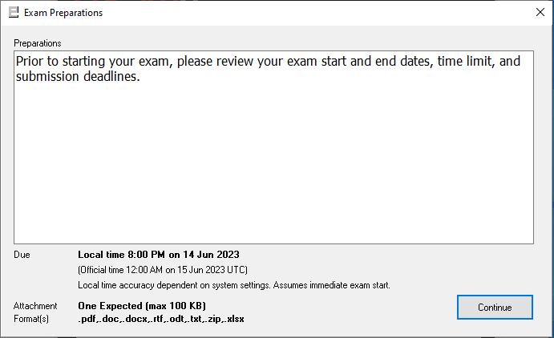
Image 4.0
- A pop-up window titled Exam Preparations will appear. This is where important information is shared before starting an exam. Highlighted is the notice to include an attachment at the end of your exam. Select Continue.

- At start-up screen #3, you can now set exam timer, font size, and font contrast preferences seen in image 5.0.
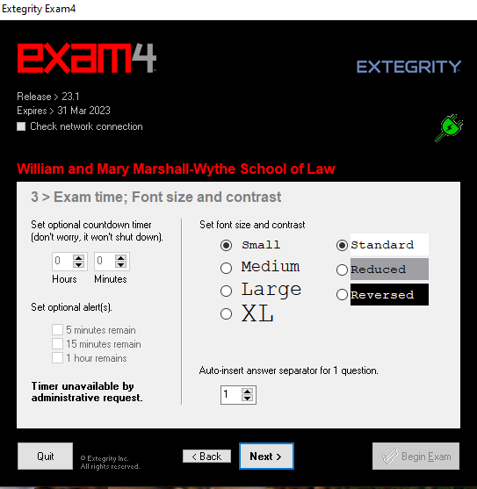
The countdown timer is optional for students. If students select this option, and upon the time-limit ending for the exam, the Exam4 software will not shut down, but the exam will be recorded as late. Accommodated students should use their adjusted time (original exam duration + accommodated time) for the timer. Note that you can also set optional alerts for time remaining.
Students can select the preferred font size and font contrast.
Students can auto-insert answer separators for exam questions. Selecting this option now means that formatting with defined lines will appear once the student starts their exam. Do not worry if you don’t know the number of questions as you’ll have a chance to enter answer separators during the exam. Once you’ve selected your preferences for start-up screen #3, select Next.

Image 5.0

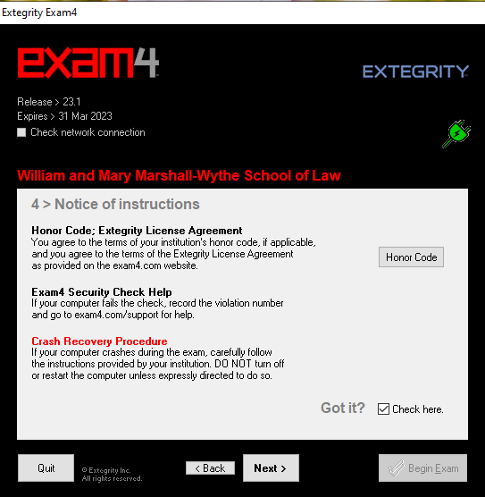
Image 6.0
- At start-up screen #4, you must read the notice of instructions carefully seen in image 6.0.
Once you’ve agreed to the Honor Code, and have read the crash recovery procedures provided on our Exam FAQ website, check the box in the bottom right-hand corner. Select Next.

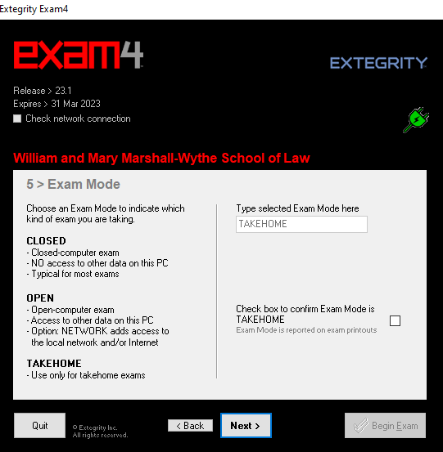
- In image 7.0, start-up screen #5 will confirm Exam Mode. Your exam mode will autofill during the actual exam. The practice exam allows students to enter each exam mode to allow students to 1) test each mode on their PC and 2) get students comfortable with each mode.

Check Box to confirm Exam Mode and click Next.

Image 7.0

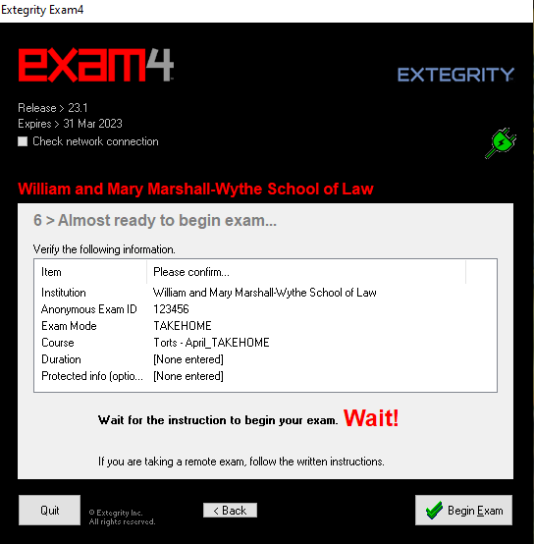
- Confirm exam details. You can go Back if you need to make changes.

When instruction is provided, or you are ready to take your remote exam, click Begin Exam seen in image 8.0.

Image 8.0

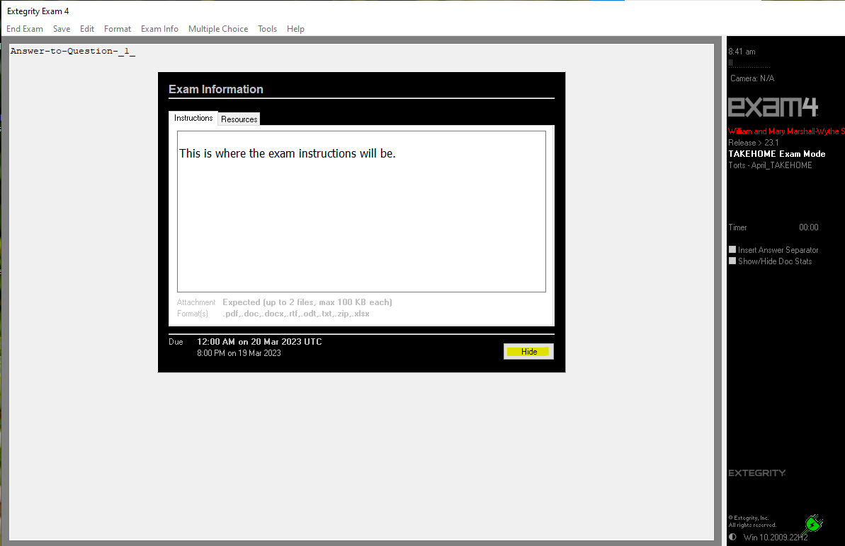 Image 9.0
- Once your exam has begun, a pop-up window will appear as seen in Image 9.0. This is where your exam instructions will appear. To view the exam questions select the Resources tab to the right of the instructions tab. Select hide to close this window.
Image 10.0
- If you selected Hide to close your instructions, you can access them again under Exam Info then Remote Exam Info.
Image 11.0
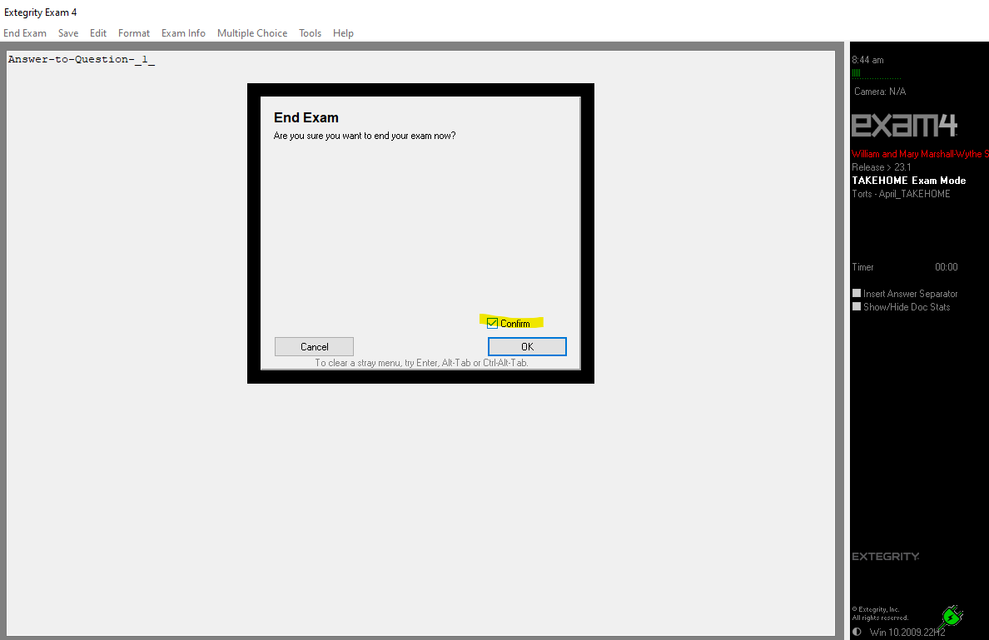
- Once you are ready to submit your TAKEHOME exam, select End Exam then End Exam now.

Image 12.0

- A pop-up window will appear. Check the box to confirm, then select OK.

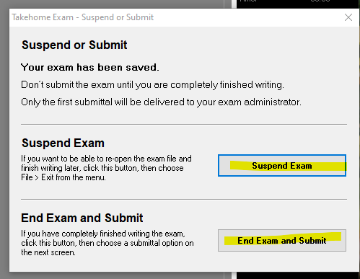

Image 13.0

- A pop-up window will appear with the options to either Suspend Exam or End Exam and Submit.
If you are not ready to submit your Takehome Exam, select Suspend Exam. This will pause your exam and permit you to resume it later. Your document will be autosaved and you will exit the Exam4 Software.
Takehome exam FAQ:
My takehome exam is 5 hours. Can I work on it 2 hours today, take a break, and use the remaining 3 hours at a later time?
Answer: Once you begin your Takehome exam, in this case, you have 5 hours to complete and submit the exam. The 5 hour limit begins as soon as you begin the exam and will continue running regardless of how many times or how long you choose to suspend the exam. i.e., if you open the exam and suspend it for 4.5 hours, then you will only have 30 minutes to work on the exam and submit it, or it will be counted late.
DO NOT SELECT ‘END EXAM AND SUBMIT’ UNLESS YOU ARE FINISHED.
See below for instructions concerning submission.

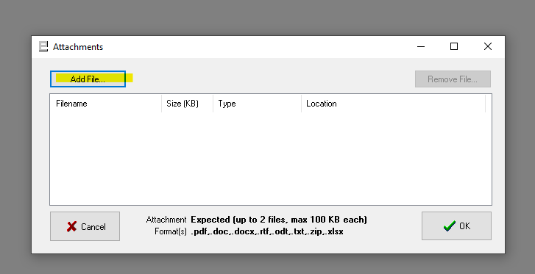
Image 15.0
- Once you’ve selected ‘End Exam and Submit’, you will be prompted to add an attachment. Click Add File and select your Exam answers from your computer.
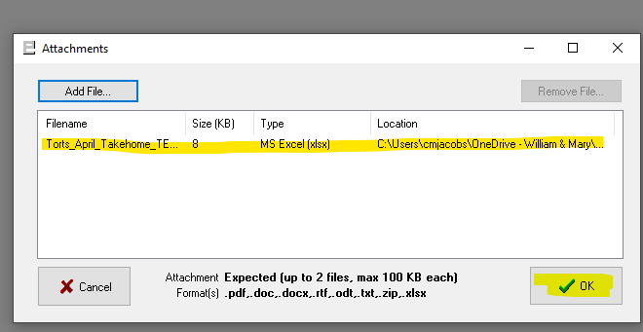

Image 16.0

- Once you have selected your Exam answers, you should see the filename in the dialog box. Confirm it is the correct file(s) and select OK.

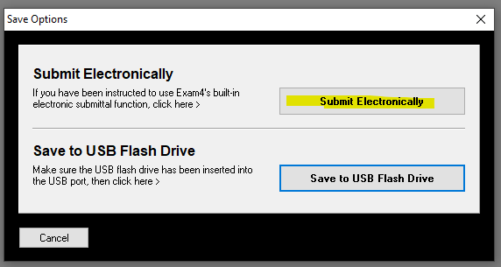 Image 17.0
- Click Submit Electronically.
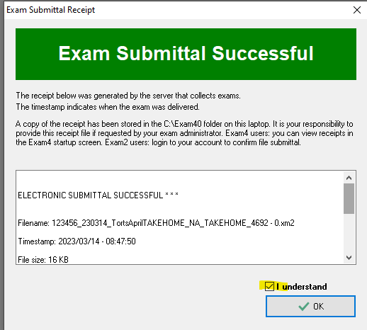
- Once you select Submit Electronically, you will see the Exam Submittal Successful box in image 18.0. You must select ‘I understand’ and click OK.

Image 18.0
Image 19.0
- After clicking OK, click Exit Exam4, then click Exit Exam4 now.
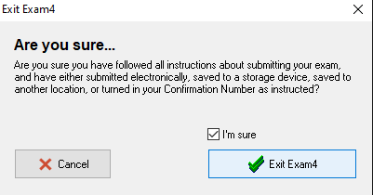 Image 20.0
- Click, “I’m Sure’ and click Exit Exam4 to close the software in image 20.0.

